Homework for week 1, submission deadline 23:59 on Sunday night.
1. Complete an Omics-to-Question map: Using your own research project or biological interest. What kind of omics you plan to use to solve the biological research question?
研究问题：藻类在高光胁迫环境下，通过哪些分子机制实现光保护响应，抵御强光带来的氧化损伤？
选用组学：
①转录组学：解析强光处理前后藻类基因表达水平的变化，找到显著上调 / 下调的基因，挖掘参与光保护、抗氧化通路的候选基因，回答哪些基因在转录层面参与高光胁迫应答。
②蛋白质组学：检测胁迫条件下蛋白质丰度与蛋白修饰的改变。基因转录不等于蛋白表达，蛋白组可以反映实际执行生理功能的蛋白，回答哪些功能蛋白参与光保护反应。
③代谢组学：测定胞内代谢物如抗氧化物质、光合中间产物等含量变化，反映细胞生理表型，回答高光胁迫下细胞代谢产物如何重编程，以此对抗氧化损伤。

2. Write one weak prompt and one CARE+V prompt: For the same biological or research question, propose a weak and strong (CARE+V) prompt that can be tested by AI. Use any LLMs to test your prompt and paste the output results below.
Weak prompt：讲讲藻类的光抑制现象
Output：
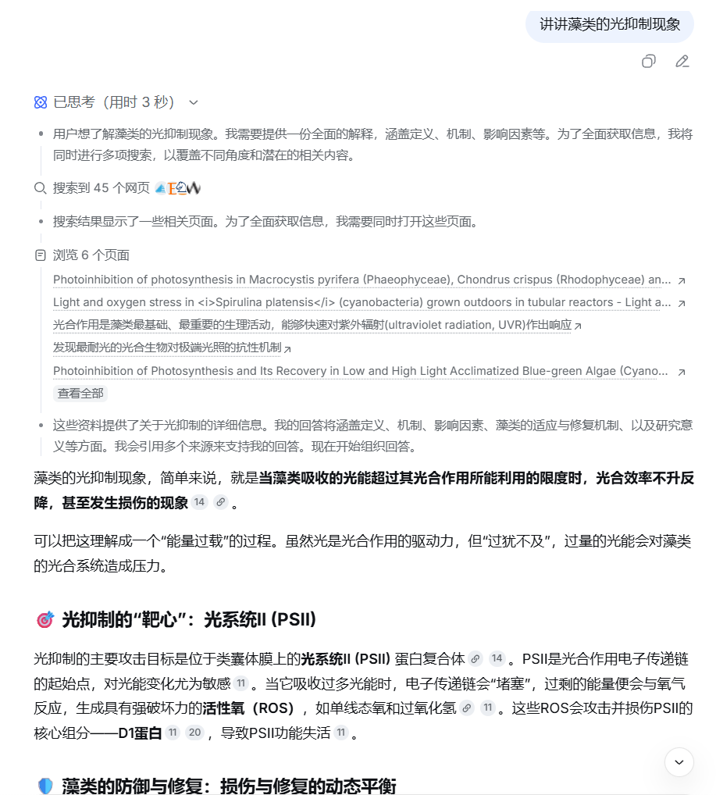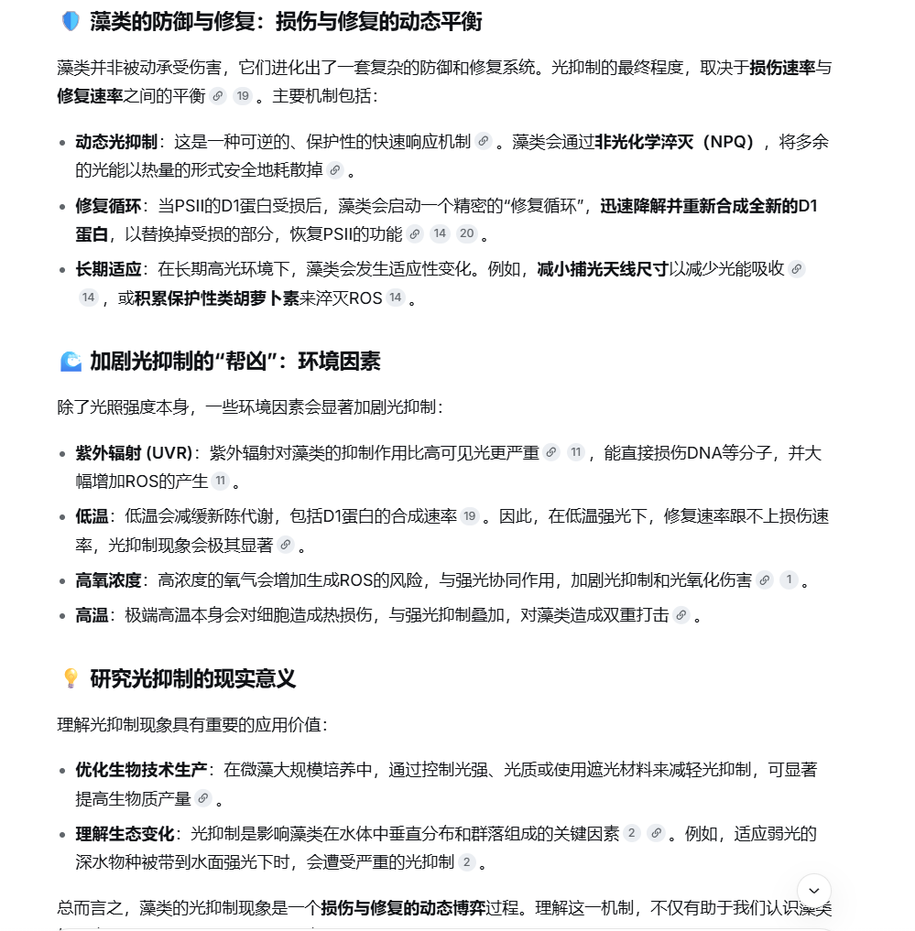
CARE+V:
【C-Context 背景】微藻进行产氧光合作用。过高光照会引发光抑制，降低光合效率，损伤光系统 II（PSII）。回答面向本科分子生物学水平。
【A-Assignment 任务】解释藻类在强光下发生光抑制的分子机制。
【R-Requirements 要求】
- 区分光损伤过程和光保护过程。
- 必须提到 D1 蛋白的损伤与修复循环。
- 输出分为 3 个短段落。
- 专业名词附带简要解释，不要堆砌晦涩术语。
【E-Example 示例】第一段：简要定义光抑制；第二段：阐述光系统 II 中 D1 蛋白损伤机制；第三段：总结藻类主要光保护策略。
【V-Validation 校验】确认回答对象是藻类，不要大量讲陆生植物；确认已经覆盖 D1 蛋白周转这一核心知识点。
Output:
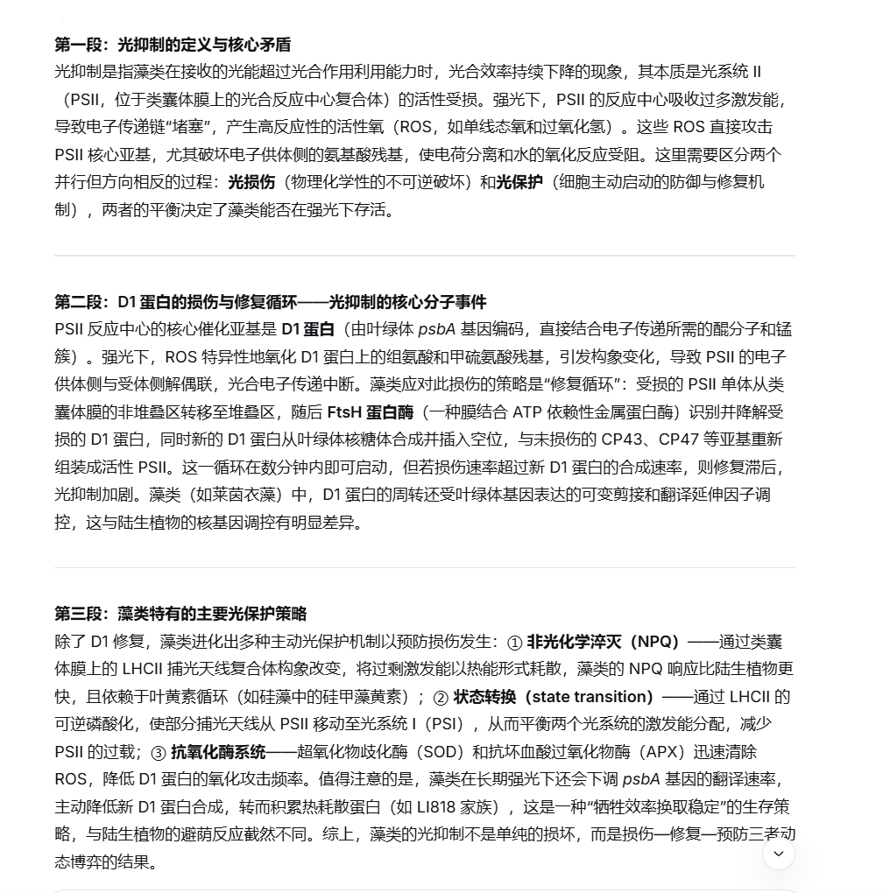

3. Install and Run R and RStudio and save output showing R version and packages.
R: https://cran.r-project.org/ RStudio: https://posit.co/products/open-source/rstudio.
Once installation, please paste a screen cut of Rstudio here. Give a try of R to using the foler (Week1_R_RStudio_Practice_Files) code and data.
Rstudio screen cut：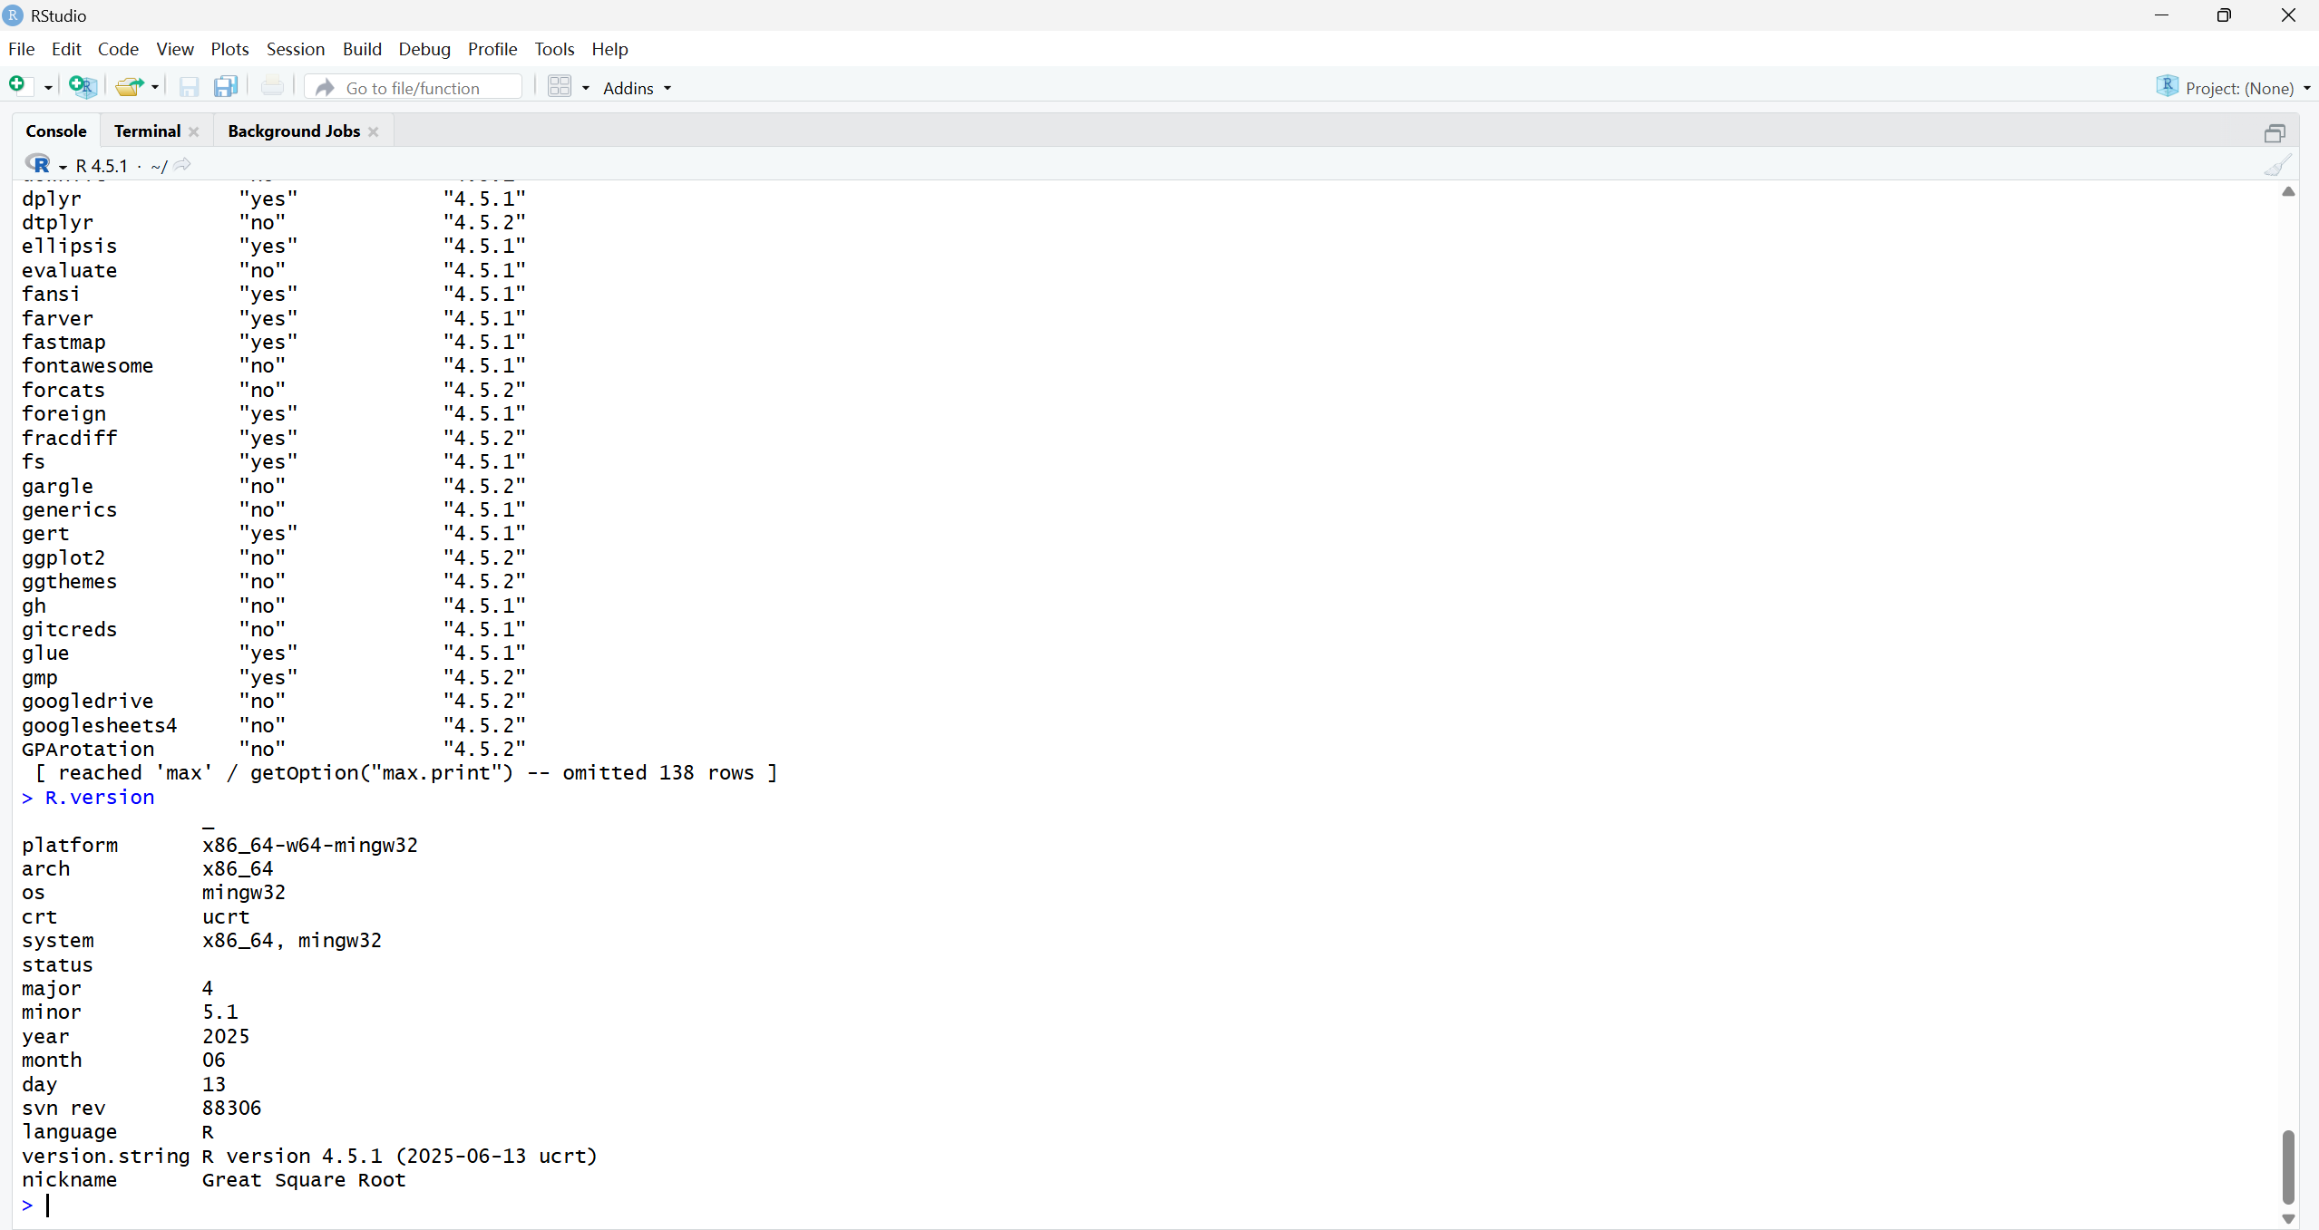
R version and packages：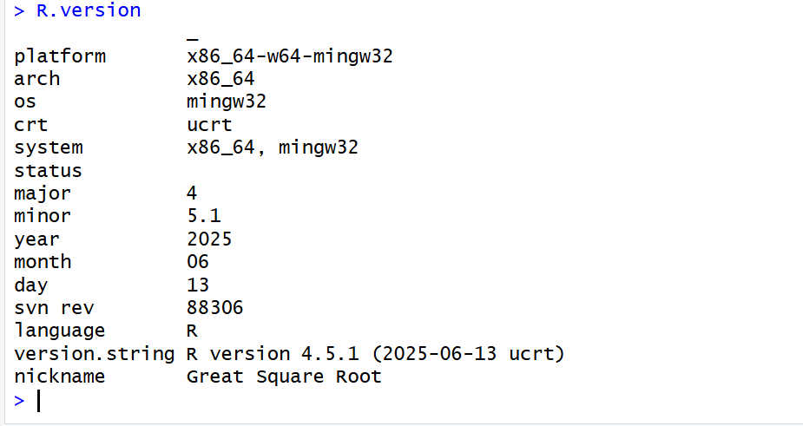
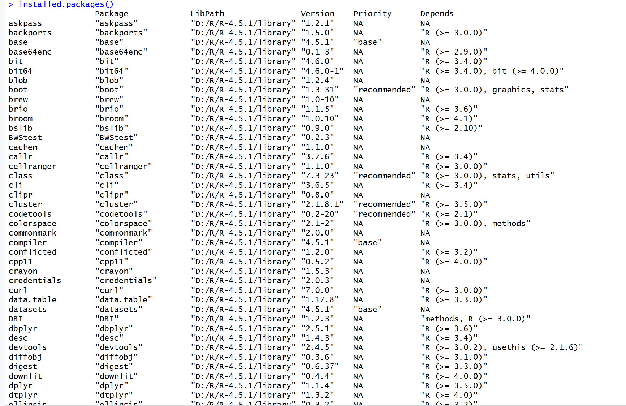
运行结果：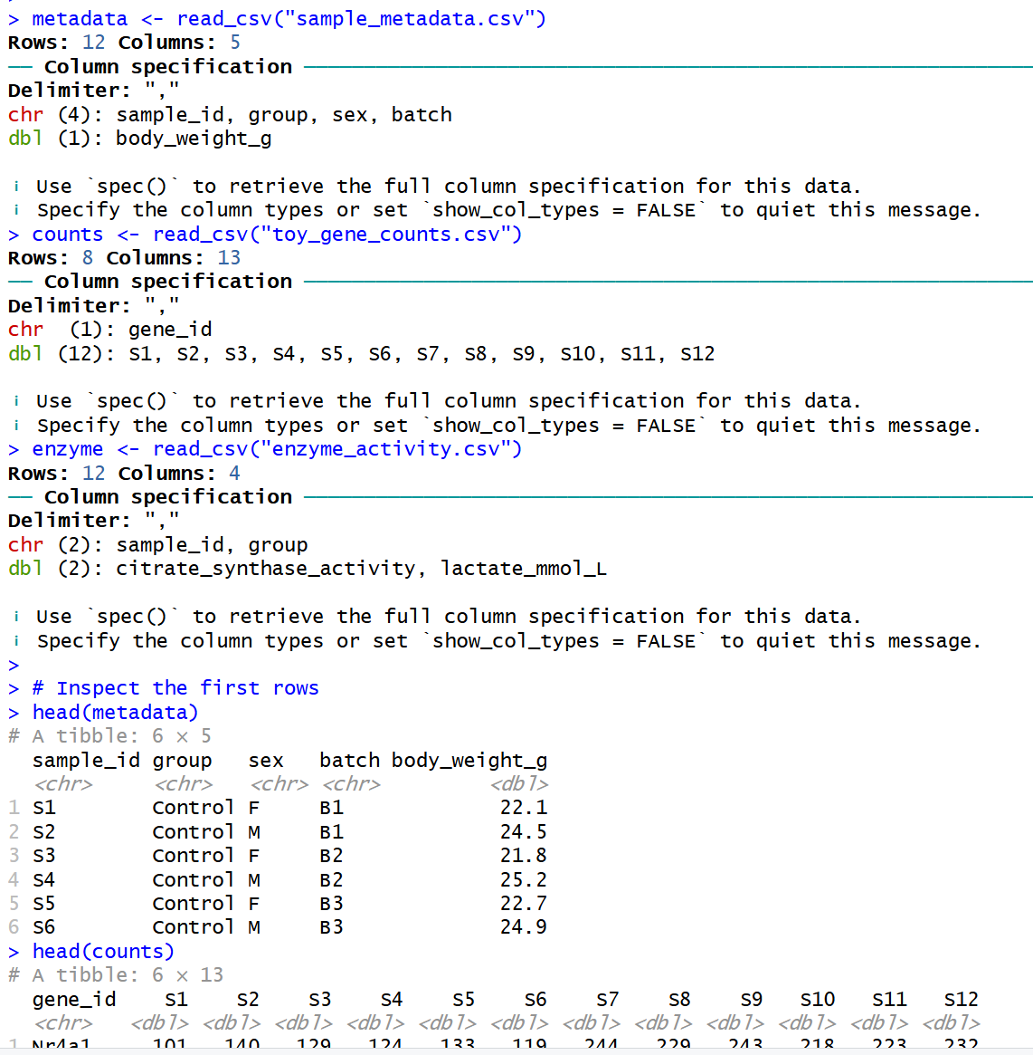

4. Install agent and create your first prompt log entry documenting AI use and verification.
4.1 Github:https://www.github.com/ (Create your account and repository for your homework submission). You need an account and a repository for homework submission (following the pattern: Bioinformatics_homework_Yourname_ID). You also need personal access token in together with repository link to activate your EasyMultiProfiler-web account.
4.2 Hermes-agent: https://github.com/NousResearch/hermes-agent (Install agent for coding) and Hermes WebUI (https://github.com/nesquena/hermes-webui)
4.3 Codex: https://chatgpt.com/codex/ (Install for coding and agent)
4.4 Deepseek API: https://platform.deepseek.com/usage (Top up ¥10 for agent set and switching to LLM accessed only on SUAT campus) or NVIDIA API
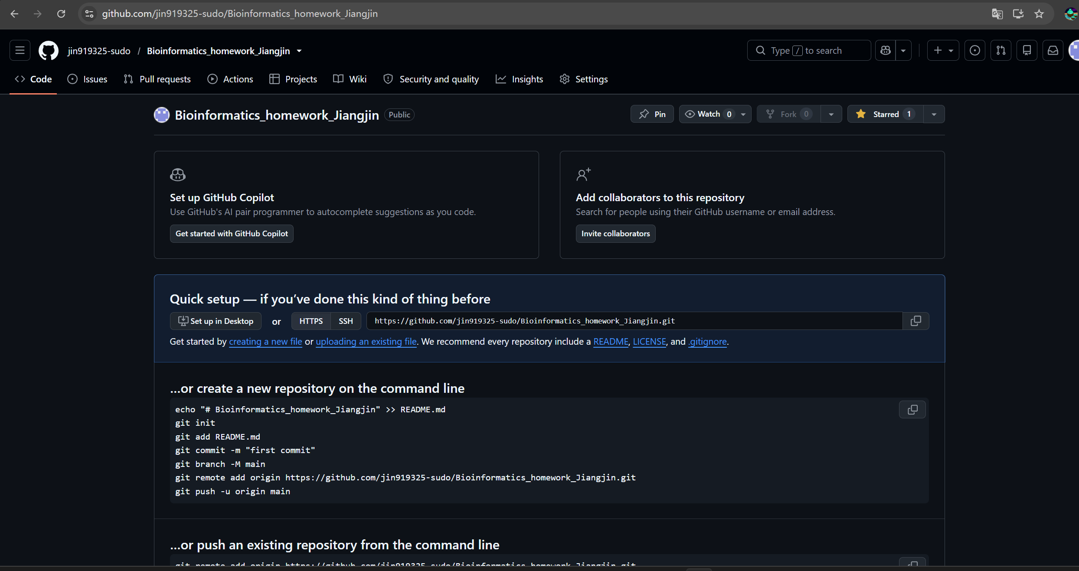
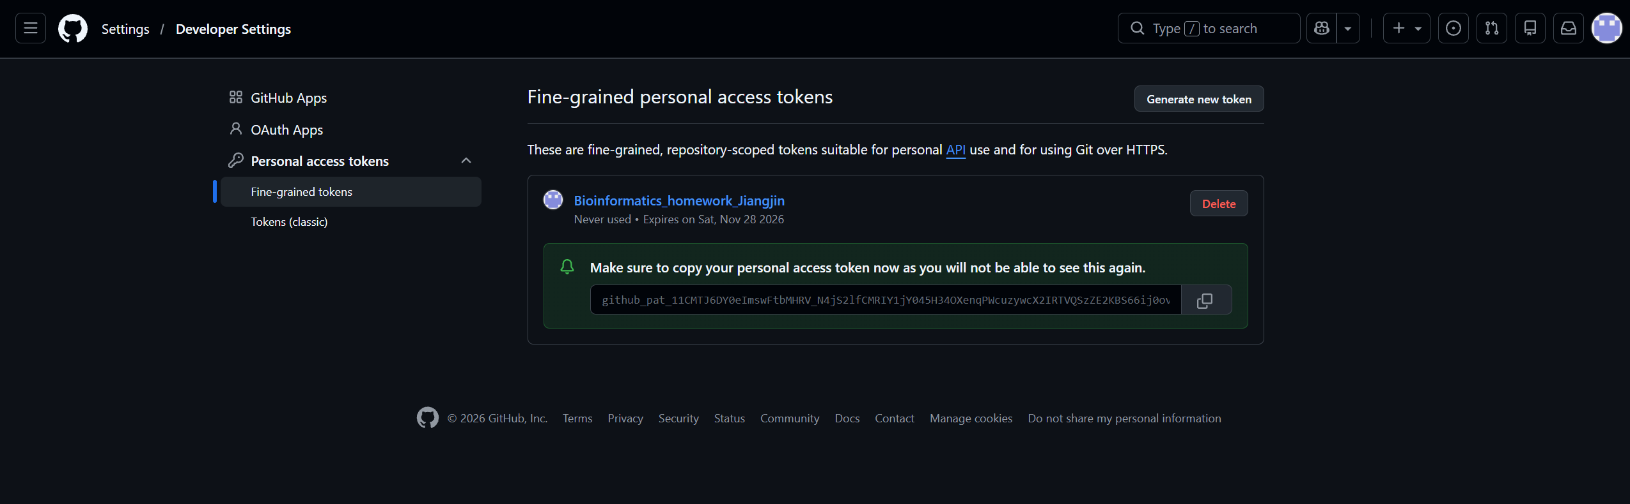
Hermes：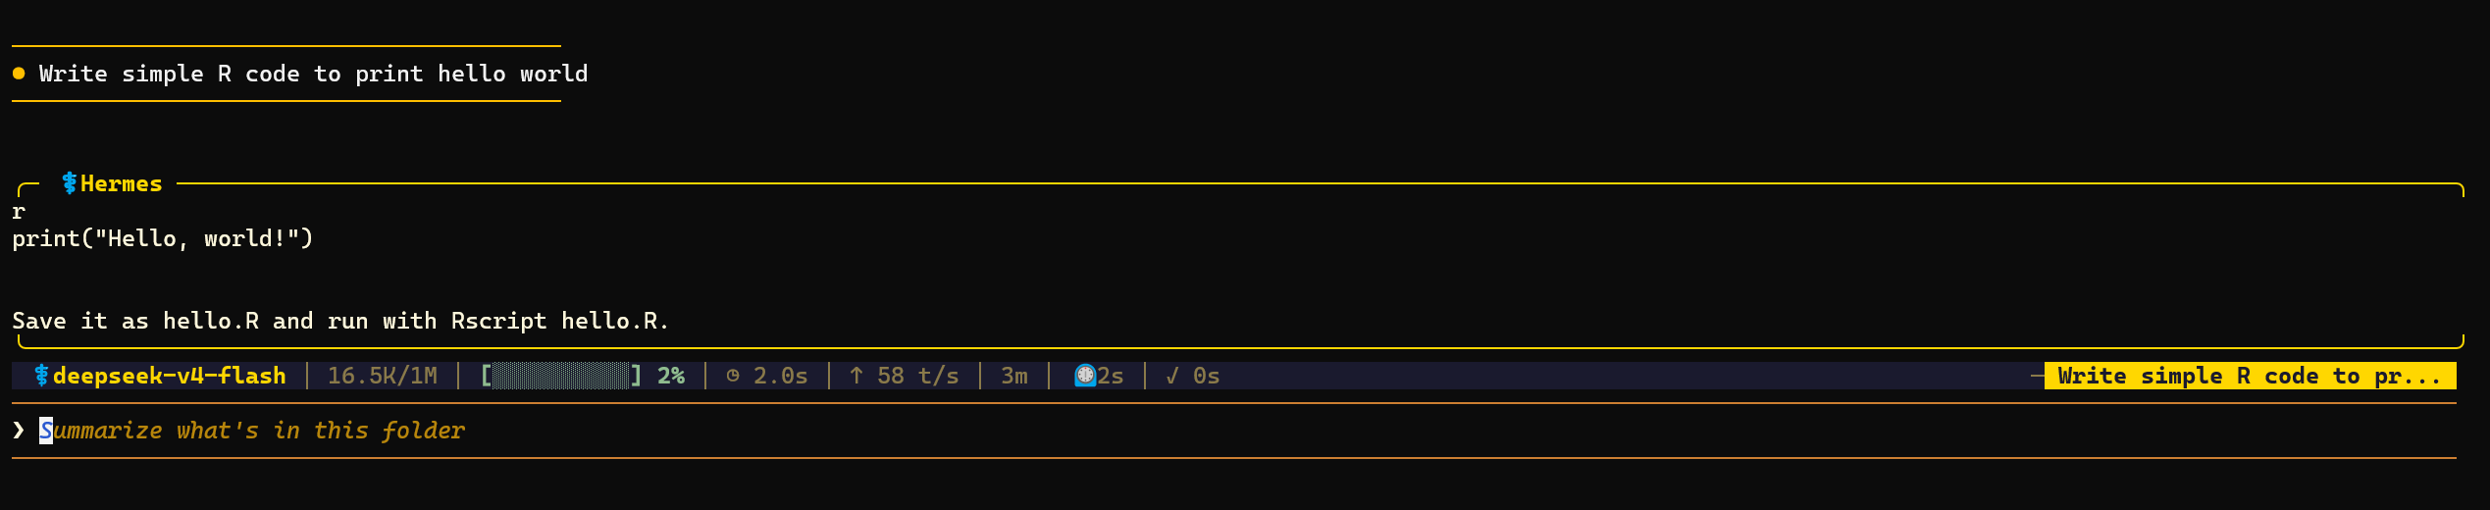
Deepseek：
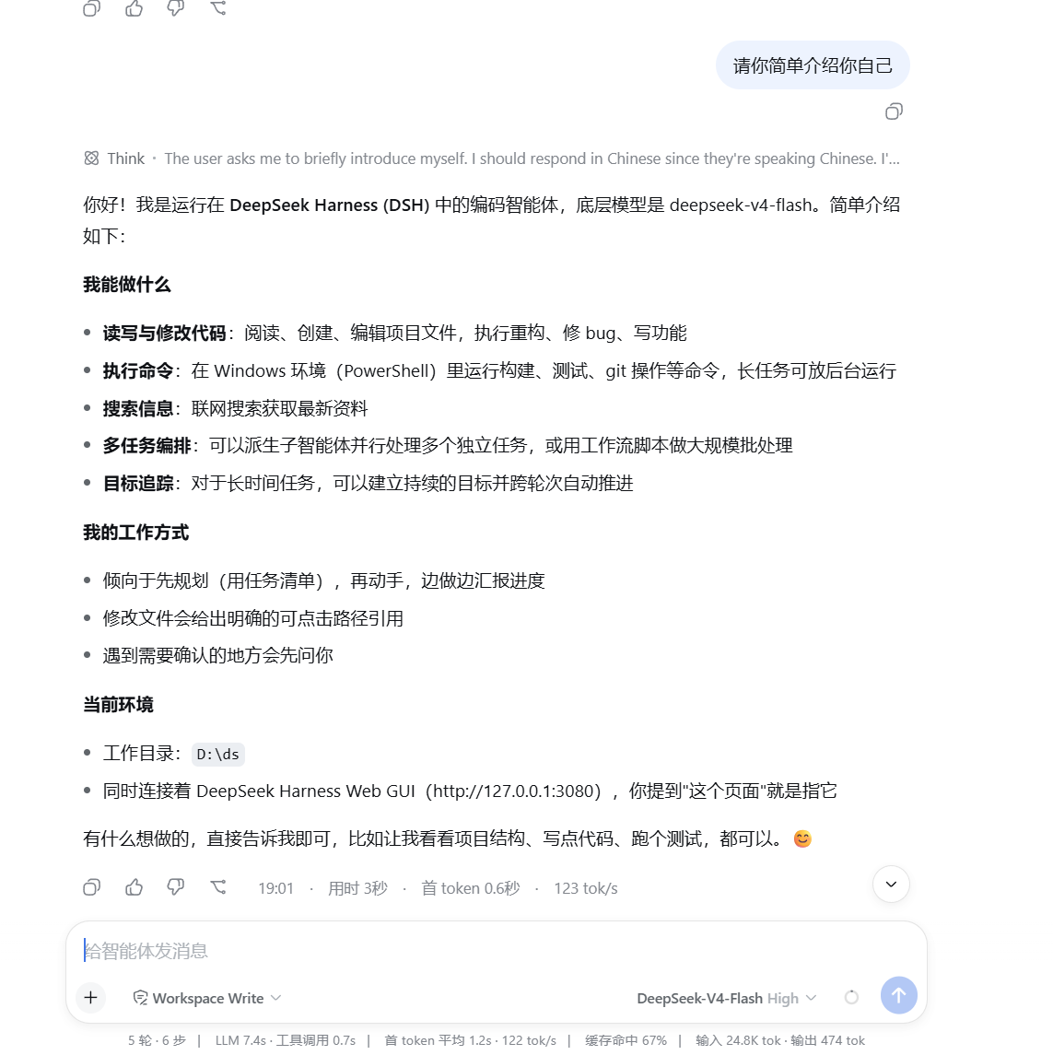

5. Install EasyMultiProfiler and EasyMultiProfiler-Web for multi-omics data analysis and homework submission (You can use Hermes or Hermes WebUI to complete the installation step)
EasyMultiProfiler: https://github.com/liubingdong/EasyMultiProfiler
EasyMultiProfiler-Web: https://github.com/xielab2017/EasyMultiProfiler-Web
